From
D. Maljers, J.H. ten Veen, M. den Dulk

Subject
Description Uncertainty procedure DGM-deep

Introduction to Uncertainty modelling
The DGM-deep model provides the end-user with a regional subsurface layer model that represents the onshore geological structures of the Netherlands. Although the 250 m resolution of the model prohibits decision making on a very small scale, e.g. for hydrocarbon reservoirs studies, it is widely used by variety of end users to support policy making. In order to assess the usability and reliability of the DGM-deep model, a measure for the uncertainty is provided.
In statistics, generally 2 types of uncertainties or errors are discriminated, i.e. accuracy and precision, as is illustrated in Figure 1A. Whereas, accuracy reflects the proximity of a model results to the true value; precision gives information on the reproducibility of the model results, neglecting the accuracy of the underlying input data. Stochastic modelling, in which multiple realizations for each horizon are generated, produces a Standard Deviation that gives information on probability of the model. Residual grids on the other hand could be relevant in view of accuracy since they reflect the correctness of the model at the well location. In the uncertainty workflow applied, accuracy and precision are combined. This is achieved by using the residual grids in the well-tie process, such that standard deviations between the well locations are centered around the well-tied depths surfaces (Figure 1B). This process does not addresses the source of misties at well location; this is subject of further research.
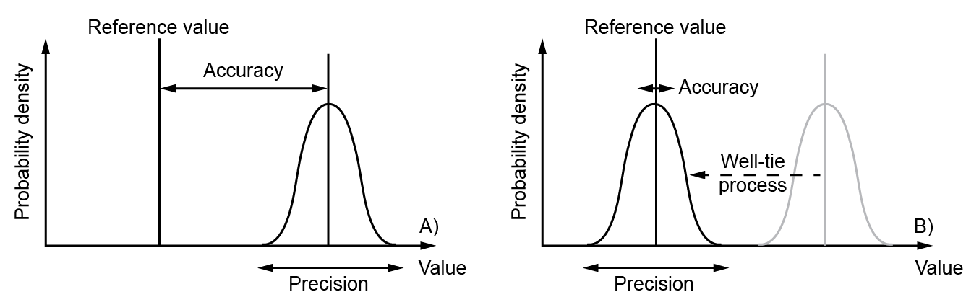
Figure 1 A) Accuracy is the proximity of measurement results to the true value; precision, the repeatability, or reproducibility of the measurement. B) Combined accuracy-precision workflow applied to DGM-deep.

Stochastic uncertainty modeling
In order to present a measure for the probability of the depth of the modelled layers, we developed a stochastic uncertainty workflow. This workflow consists of building time maps for each horizon from seismic interpretations that are subsequently converted to the depth domain using an acoustic velocity model (VELMOD-3), taking into account the potential error bandwidth for each data source. A stochastic simulation algorithm (Sequential Gaussian Simulation, SGS) is applied in order to generate multiple random realizations for each horizon, both in time and depth domain.
The workflow takes into account the following three error sources:
- Data error: This error takes into account any error related to the picking of a horizon within a seismic dataset and includes processing errors, vertical shifting errors and resolution errors. The data error increases with depth due to decreasing quality of the seismic data. Also a larger error has been assumed for picks traced from 2D seismic than those from 3D seismic. The data error is added as a noise factor to the original horizon picks using a short correlation distance (<1 km). Each realization is conditioned to the available data but varies within the error bandwidth away from the points.
- Structural complexity: Areas characterized by low structural complexity will produce small errors with interpolation, while in structurally complex areas a larger error is introduced. Therefore, structural complexity importantly affects the uncertainty. At the location of data points, the depth values will range within the data error bandwidth. Moving away from data points, the error gradually increases up to the maximum interpolation error set by the regionally varying structural error.
- Velocity model error: For each map of V0, a set of SGS realizations has been calculated using the same interpolation and variogram settings as used in the VELMOD-3 model.

Finally, the errors are combined to a joint depth error following these steps (Figure 2):
- A random depth-dependent data error is added to all seismic horizon picks.
- A random realization of a set of time domain maps for each horizon is obtained from the SGS interpolation of the seismic horizon picks (plus error) in combination with regional structural error maps.
- A random realization of V0 maps for each horizon is obtained from SGS interpolation of all available well velocity determinations and variogram and interpolation parameters from VELMOD-3.
- A random realization of a set of depth domain maps is obtained from time-depth conversion of the realized time maps using the realized V0 maps.
- Kriging interpolation of residual well marker mismatches and the subsequent correction for these residuals ensures that the maps are conditioned to the wells used.
- Calculation of SD from the multiple realizations of the final depth maps.

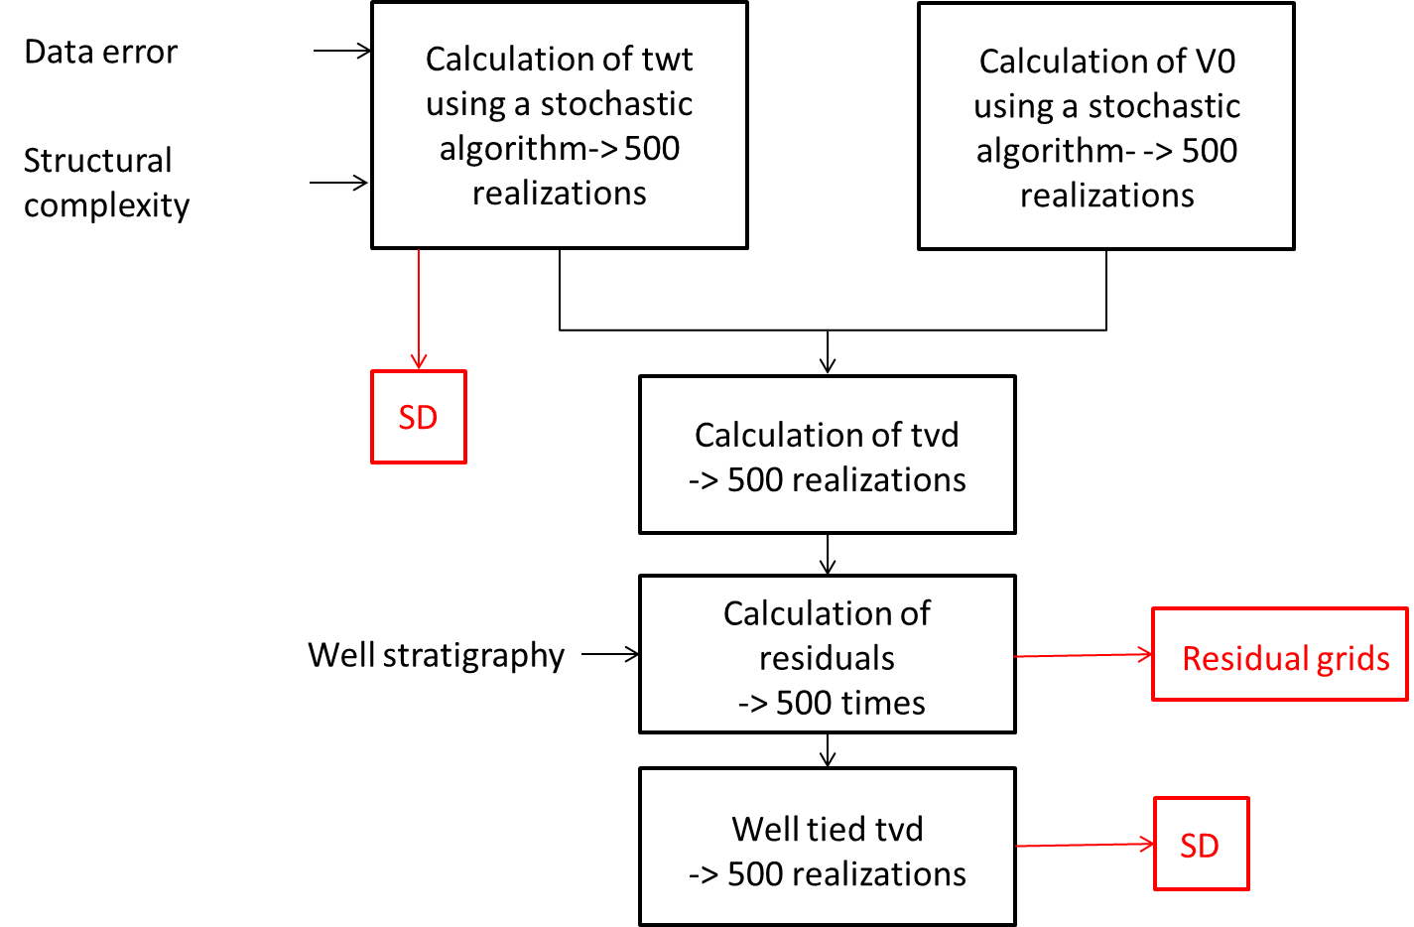

Figure 2 Workflow used to calculate the uncertainties. See text for further explanation.

How to use the uncertainty depth maps?
Uncertainties are represented as standard deviations, i.e. a statistical measure for the spread of values, in this case the SD of two way travel time (TWT) and true vertical depth (TVD). The provided DGM-deep depth map represents the best estimate of the base of a unit. However, the true base of the unit may be positioned shallower or deeper. The likelihood that the real depth value lies between the estimated value plus or minus 1 times the standard deviation is ca 64%. For a range of 2 times the standard deviation the likelihood is ca 95%. For a specific location, it can be said that the base of the unit, with 5% uncertainty, lies between the minimum and maximum. The width of the confidence interval differs for each location as it is depending upon the SD (Figure 3). Therefore, end-users that apply the mean/estimated depth map for further purposes should realize that not a single confidence value can be attached to this specific depth map, only that it is in the middle of a 95% confidence interval and therefore considered the best pick.
Figure 3 shows a cross section of the depth of the North Sea Group, the 95% confidence interval and 4 equally likely realizations out of 500 of this depth. Along the cross section, the variation in SD values (and thus the width of the 95% confidence interval) clearly stand out. For example, between 20.000 and 30.000 m a region with a low SD is visible that corresponds to a region with 3D seismic data coverage. From 30.000 m onwards, the SD dramatically increases. This part of the cross section crosses the Ruhr Valley Graben, a structurally complex area, where only 2D seismic data are available.

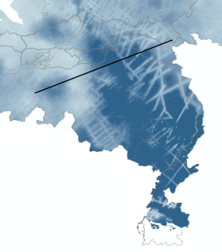
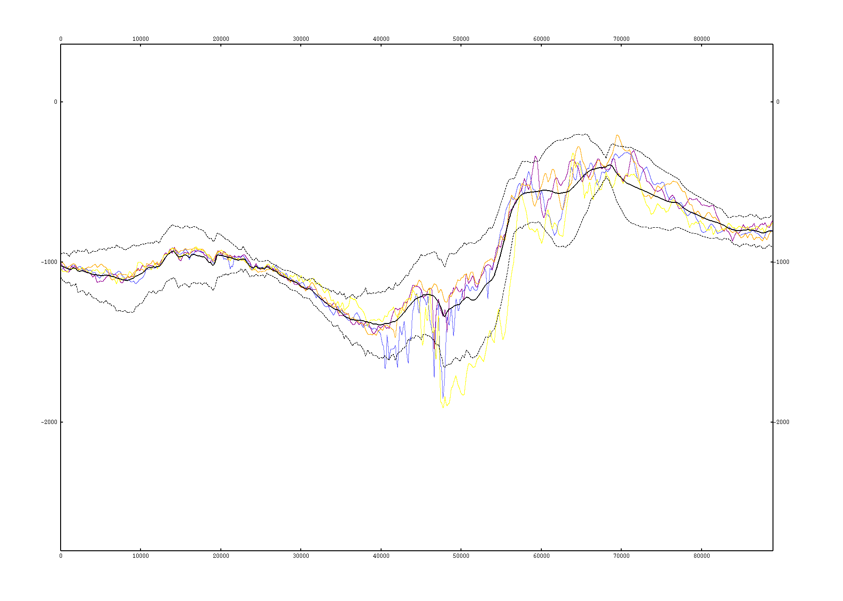
Depth [m]
Distance [m]
Figure 3 Cross section; bold black line: mean of 500 realizations of the depth of the North Sea Group; dotted black lines: 95% confidence interval; colored lines: individual realizations (4 out of 500). Map shows the SD of the depth of the North Sea Group (light blue: low SD, dark blue: high SD) and the position of the cross section.

Drawbacks of the uncertainty method
The uncertainty workflow applied is an effective way to represent the reliability of the model, but since it is built upon various error sources, the relative contribution of these individual sources may need further explanation.
For instance, data proximity appears to have more impact on the standard deviation than structural complexity and depth. This is well exemplified by the depth of the base Triassic in the West Netherlands Basin. This depth surface has a relatively low SD, even though a high standard deviation is expected based on the high structural complexity of the area. This shows that for areas covered by 3D seismic the SD may erroneously suggest a high reliability.

If for the same area well depths are considered as true depths, the mistie values, in a sense, reflect the reliability of the model at the well location. “In a sense” because extraction of mistie values and resulting residual grids are part of a deterministic approach that yields a measure for accuracy but not for precision as does the stochastic approach (see Figure 1).

Comparison of residual grids and standard deviation (SD), e.g. in the same area in the West Netherlands Basin, show that the low standard deviation correspond with large residuals. Thus, the large residuals in these areas provide additional and better information on the overall reliability of the model.

In general residual grids show large residual values in older stratigraphic intervals (CK-RB). Large residual values are furthermore observed in areas with strong variable relief such as near faults or near salt domes. Often when large residuals are observed the misties value are related to a strong relief in combination with a lack in model detail. An easy solution through local correction may be applicable without severely distorting the initial surface trend. If this solution were to be applied the residual grid will show a local severe peak at the well location. If a local correction is not acceptable the solution is much more complex. Every step in the modeling workflow, from the interpretation phase to the end product in depth may contribute to these large residual values and preferably every step needs re-evaluation, which is a time-consuming process.

